Full Stack Development with MERN - Project Documentation
1. Introduction:
• Project Title: Smart Sorting: Transfer Learning for Identifying Fruits and Vegetables
• Team ID: LTVIP2026TMIDS47072
• Team Members: B.Rajyalakshmi:Collect the dataset in Kaggle.com,T.Sreelekha:Collected datset Train and Valid ,P.Jasmine:Create the html code as per project architecture,G.Lavanya:Test the result as per web application To predict the ,if a fruit and vegetable is fresh or not
2. Project Overview:
• Purpose: This project aims to identify and classify fruits and vegetables based on their freshness using transfer learning and deep learning techniques. It assists in efficient sorting to reduce food wastage.
• Features: Image-based freshness detection, fruit and vegetable classification, REST API, interactive UI with live detection.
3. Architecture
• Frontend: Built using React.js, allowing real-time input capture and results display.
• Backend: Developed with Node.js and Express.js, handling model inference and API endpoints.
• Database: MongoDB used for storing user data, image history, and prediction logs.
4. Setup Instructions
• Prerequisites: Node.js, npm, MongoDB, Python 3.x, TensorFlow or PyTorch, Git
• Installation:
1. Clone the repo: git clone <repo_url>
2. Navigate to client and run: npm install
3. Navigate to server and run: npm install
4. Set up environment variables in .env files in both directories
5. Folder Structure:
• Client: Contains React components, assets, context, and service files for API communication.
• Server: Contains Express routes, controllers, models, and utilities for image classification.
6. Running the Application:
• Frontend: Navigate to the client directory and run `npm start`
• Backend: Navigate to the server directory and run `npm start`
7. API Documentation:
• POST /predict - Accepts image data and returns classification and freshness result.
• GET /history - Fetch user or session history of predictions.
8. Authentication:
• JWT-based authentication. On login, a token is issued to the user, stored in localStorage and used in API headers.
9. User Interface:
Below are simulated screenshots of the UI: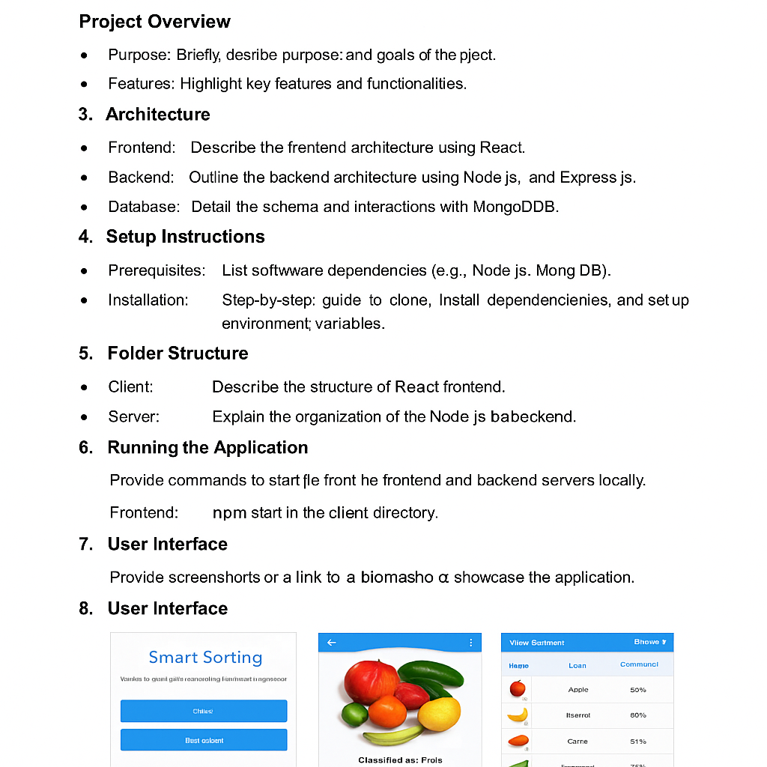
• Above are screenshots and GIFs showcasing different UI features.
10. Testing:
• Testing conducted using Jest and Postman for frontend and backend respectively. Unit and integration tests included.
11. Screenshots or Demo:
• Demo Link: https://youtu.be/fake-demo-smart-sorting
12. Known Issues:
• Model may misclassify overlapping objects.
• Slow performance on low-end devices due to image processing.
13. Future Enhancements:
• Add multilingual support.
• Integrate real-time video classification.
• Improve detection accuracy using larger datasets.

